**CURRICULUM VITAE**

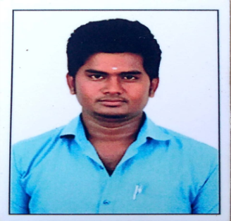

**NISHANTHAN.R**

133, VAZHUTHIGAIMEDU,

NAYAUR (PT), SHOZHAVARAM (VIA),

CHENNAI – 600067.

**E-mail**: nishanthravi1993@gmail.com

**Mobile Number**: 9944691846

**OBJECTIVE:**

To seek out a challenging career in the field of Electrical and expand my domain knowledge and develop innovative solutions and provide good quality of service .

**ACADEMIC QUALIFICATION:**

|  |  |  |  |
| --- | --- | --- | --- |
| **Education** | **Institute** | **Year of Passing** | **Percentage** |
| B.E, Electrical and Electronics Engineering | Arignar Anna Institute of Science and Technology- Anna University | 2016-2019 | 71.4% |
| Diploma in Electrical and Electronics Engineering | Thirumalai Polytechnic college - Anna University | 2012-2014 | 84% |
| Higher Secondary | Government Boys Higher Secondary School | 2011-2012 | 48.0% |
| SSLC | Government Boys Higher Secondary School | 2009-2010 | 62.5% |

**INTELLECTUAL PROJECT:**

**B.E** Implementation of PV based high step-up boost converter and

z-source inverter system

**Diploma**  Speed Control of PMDC Motor Using Fuzzy Logic

**MINIATURE –PROJECT TITLES:**

* Dark lamp method
* Wind power plant with Capacitor bank

**ACHIEVEMENTS:**

* Attended internship training in VOLTECH Engineers Private Limited for 1 week.
* Completed implant training for FIVE days in ENNORE THERMAL POWER PLANT.
* Certification course of Diploma in Computer Application at SRM Center.
* Attended internship training in BSNL for 1 week.

**EXPERIENCE:**

* Supervisor at ASHOK LEYLAND in LEEWAY Logistics (2014-2015)
* Operator at NOKIA SIEMENS NETWORK in IKAY Contracts (2015-2016)

AREAS OF INTEREST:

* AWS (EC2, S3, Cloud Watch, ELB & VPC ,Redshaft)
* DevOps (Jenkins, Github, Docker)
* Linux

**PERSONAL PROFILE:**

**Father’s Name** : Mr. M .Ravi

**Mother’s Name** : Mrs. R .Dhanalakshmi

**Date of Birth** : 20 Sep 1993

**Languages Known** : English, Tamil.

**Hobbies** : Playing chess, listening music.,

**MY STRENGTH:**

* + Being ready to accept failure without giving up my self confidence
  + Self motivated, punctual, and I'm willing to learn.

**ASSERTION:**

I hereby affirm that all the details furnished above are spot on to thepreeminent of my knowledge.

**Place: Signature**

**Date: [NISHANTHAN.R]**